**DATABASE CONNECTIVITY USING TALEND STUDIO-**

1. Download and install mysql 5.5 from this link-

<https://dev.mysql.com/downloads/windows/installer/5.5.html>

Note- Talend open studio only supports mysql 4 and mysql 5.

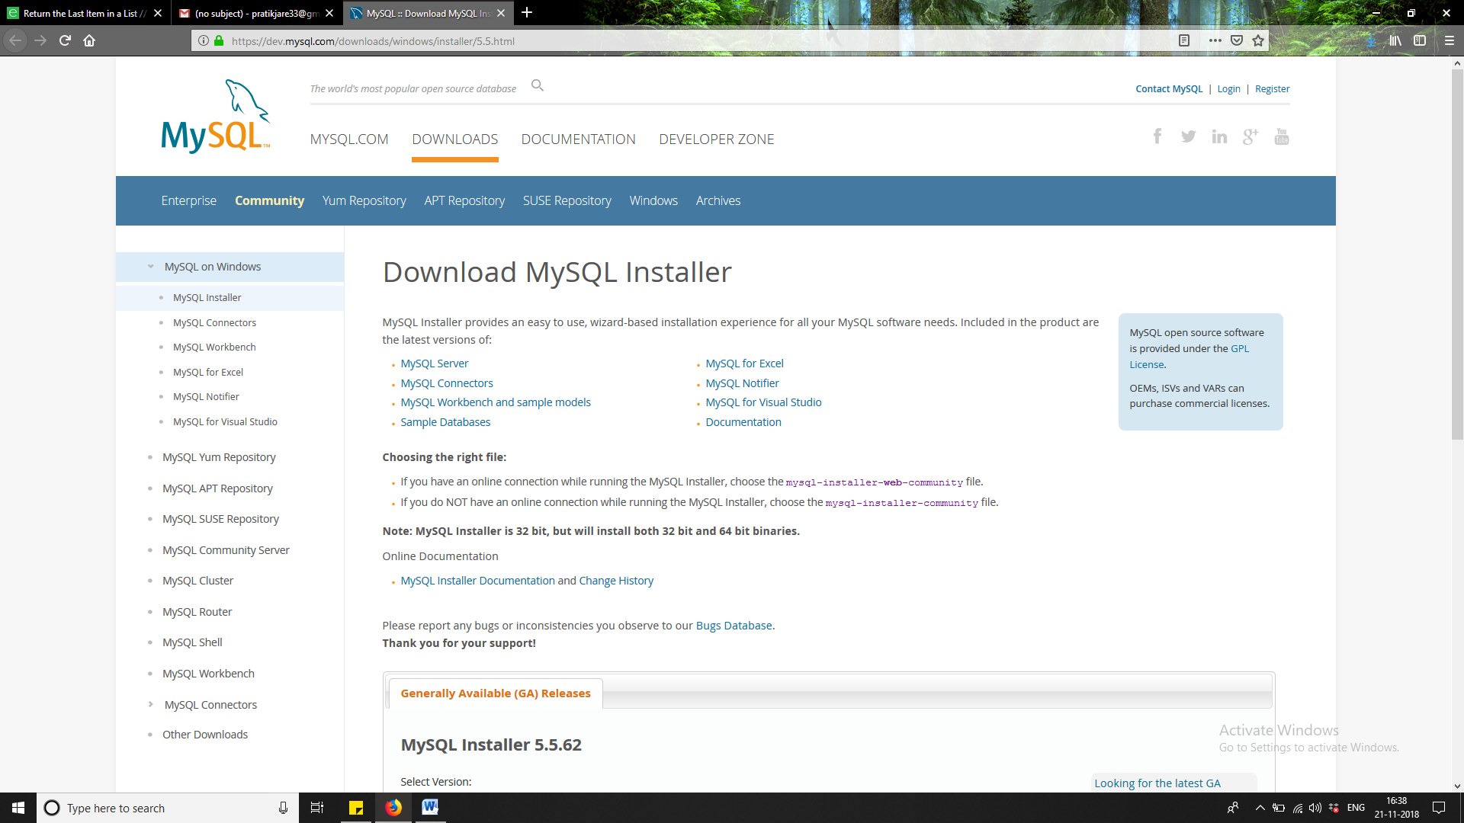

1. While installing mysql 5 , fill all the details carefully. Otherwise watch this video on installing mysql.

<https://youtu.be/WuBcTJnIuzo>

1. Open talend studio. Create a new Project.

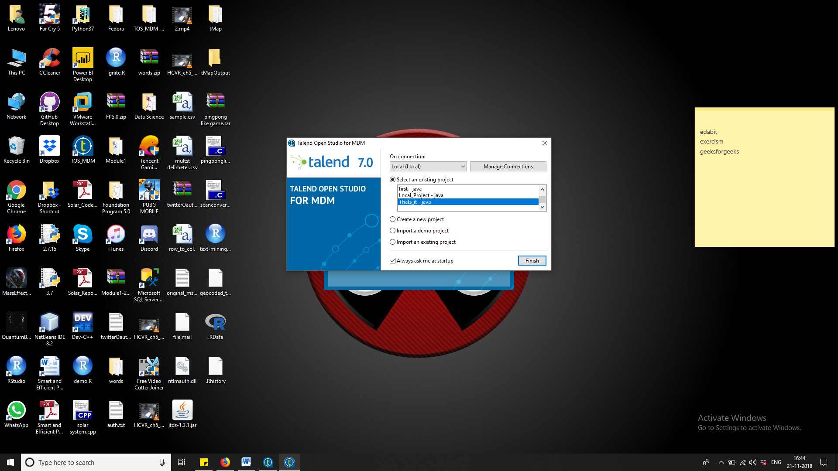

1. Go in integration on your Right upper corner. Then go in metadata on your left side of the screen. Expand metadata. Right click on database connection. Select create connection.Give any name of Your wish.

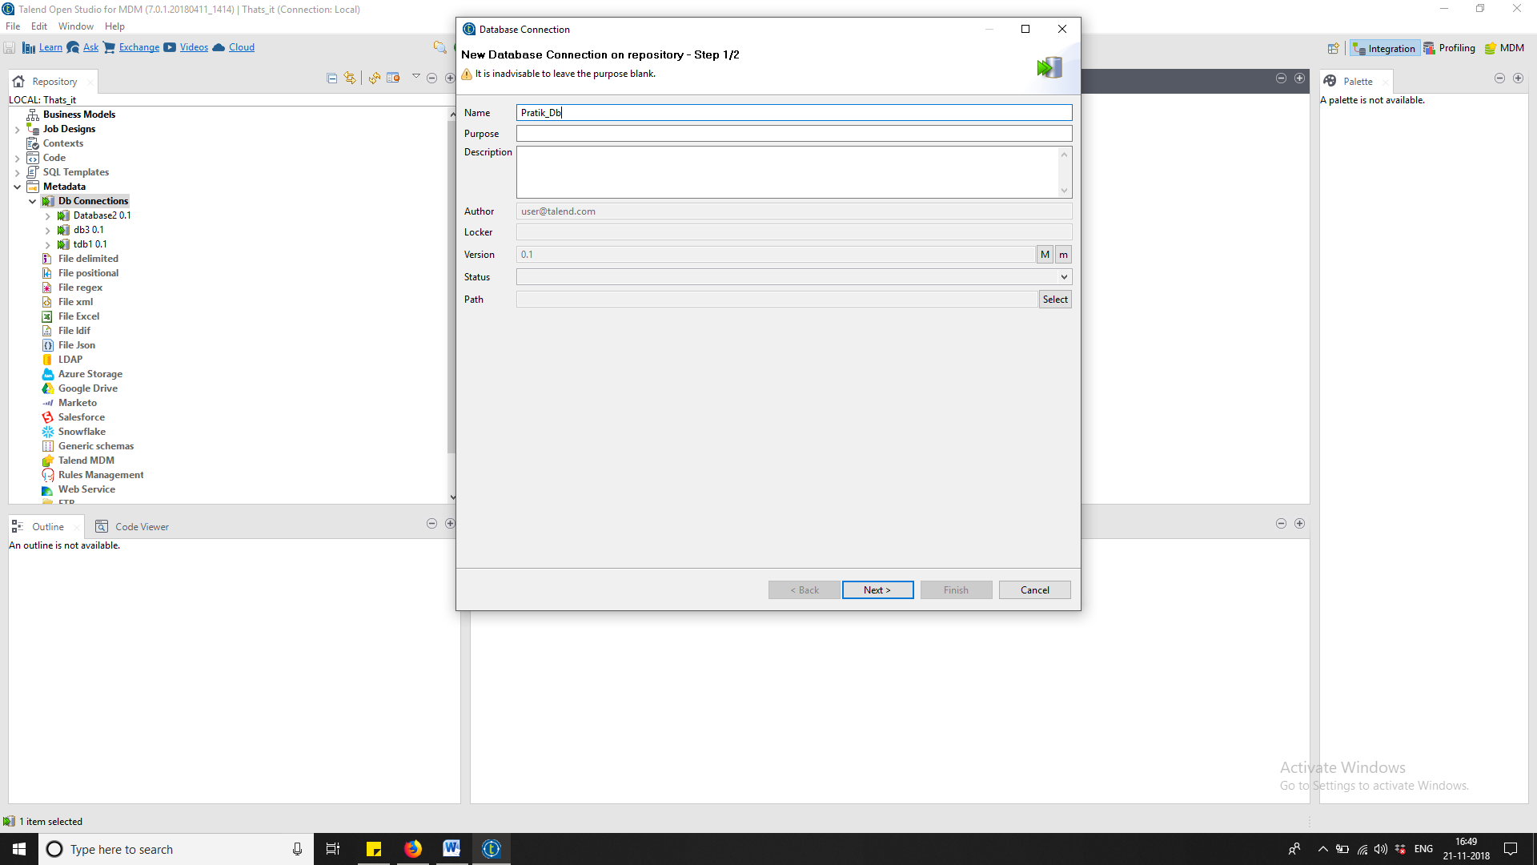

1. First select db which is mysql, then all the details. Login and password are which have set during installation of mysql 5.5. After filling the details click on test connection.

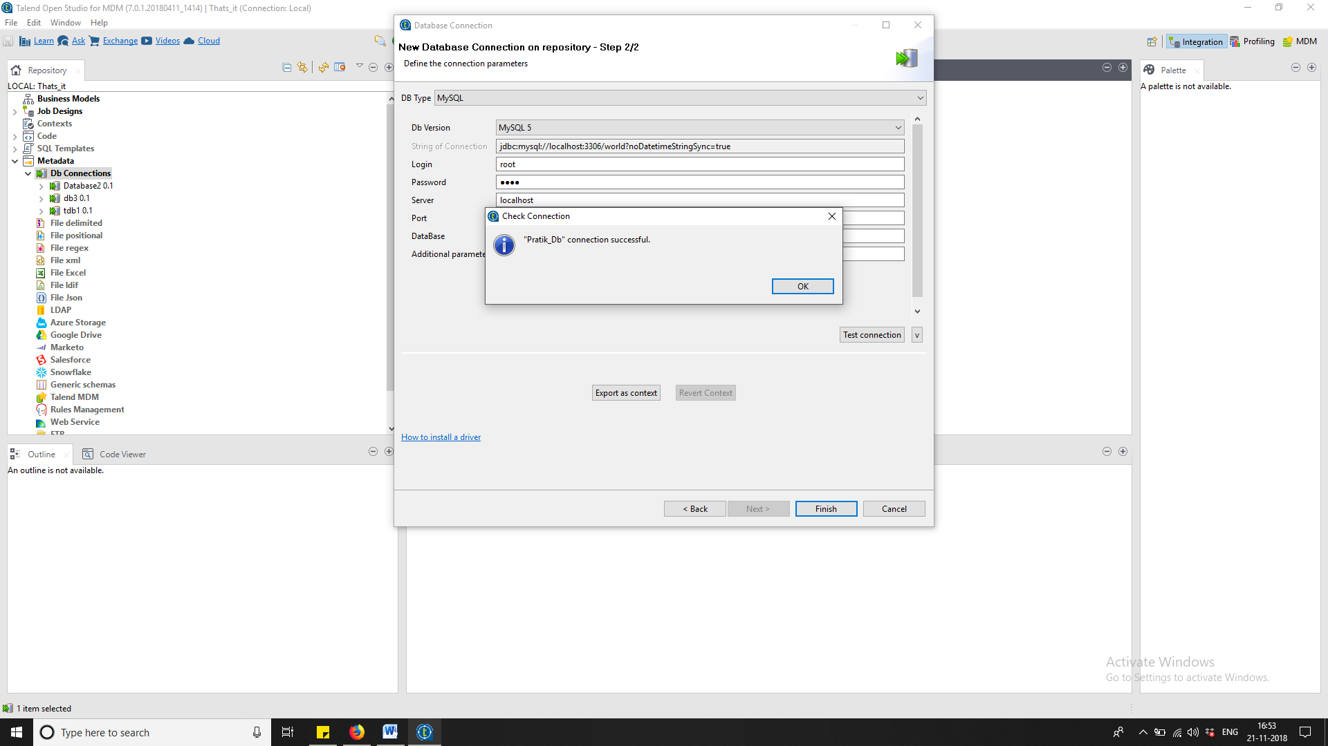

1. Go on that database which you have created and click on retrieve schema.

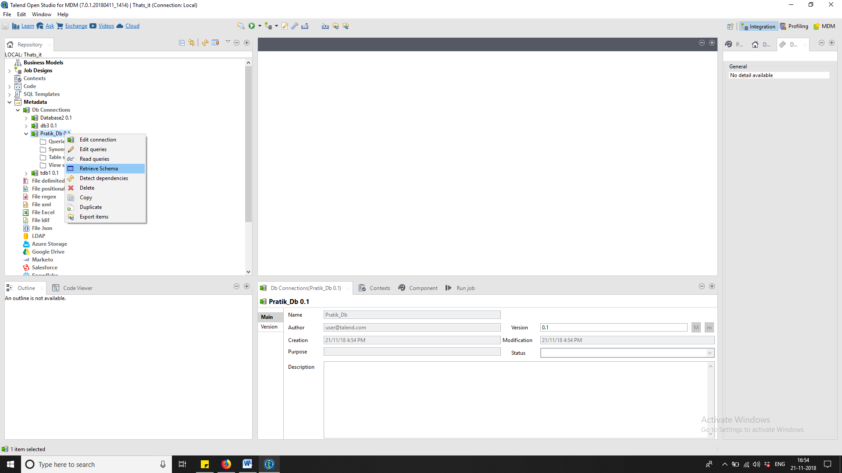

1. While retrieving the schemas we are extracting all the data from our database world. Select all the tables. And then press Next.

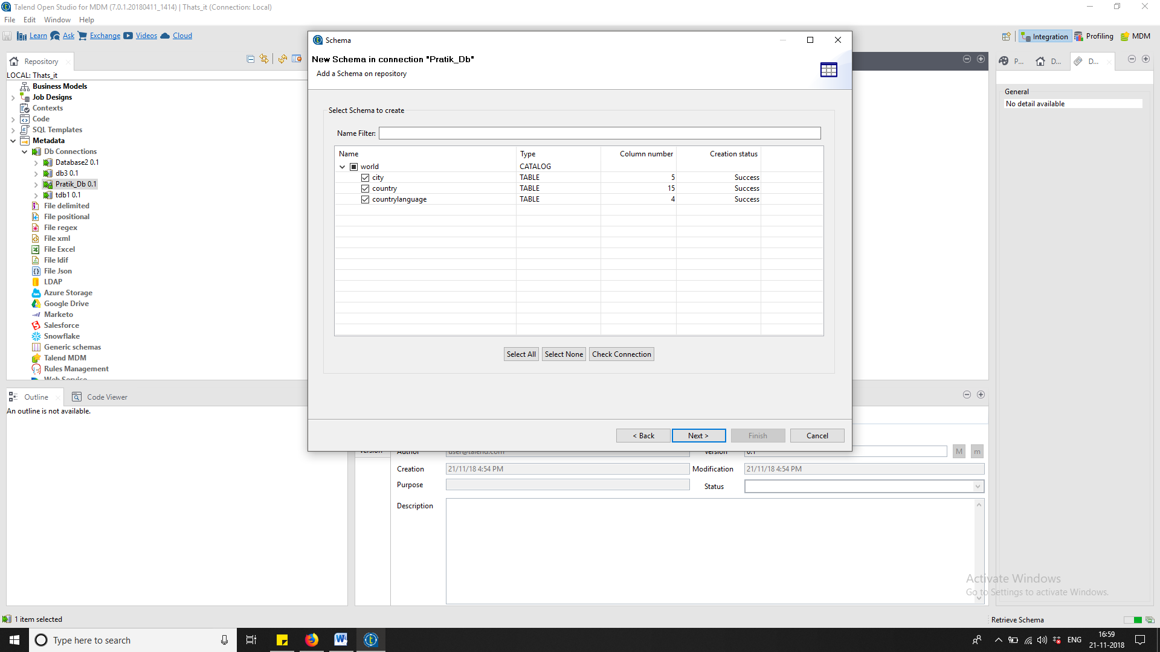

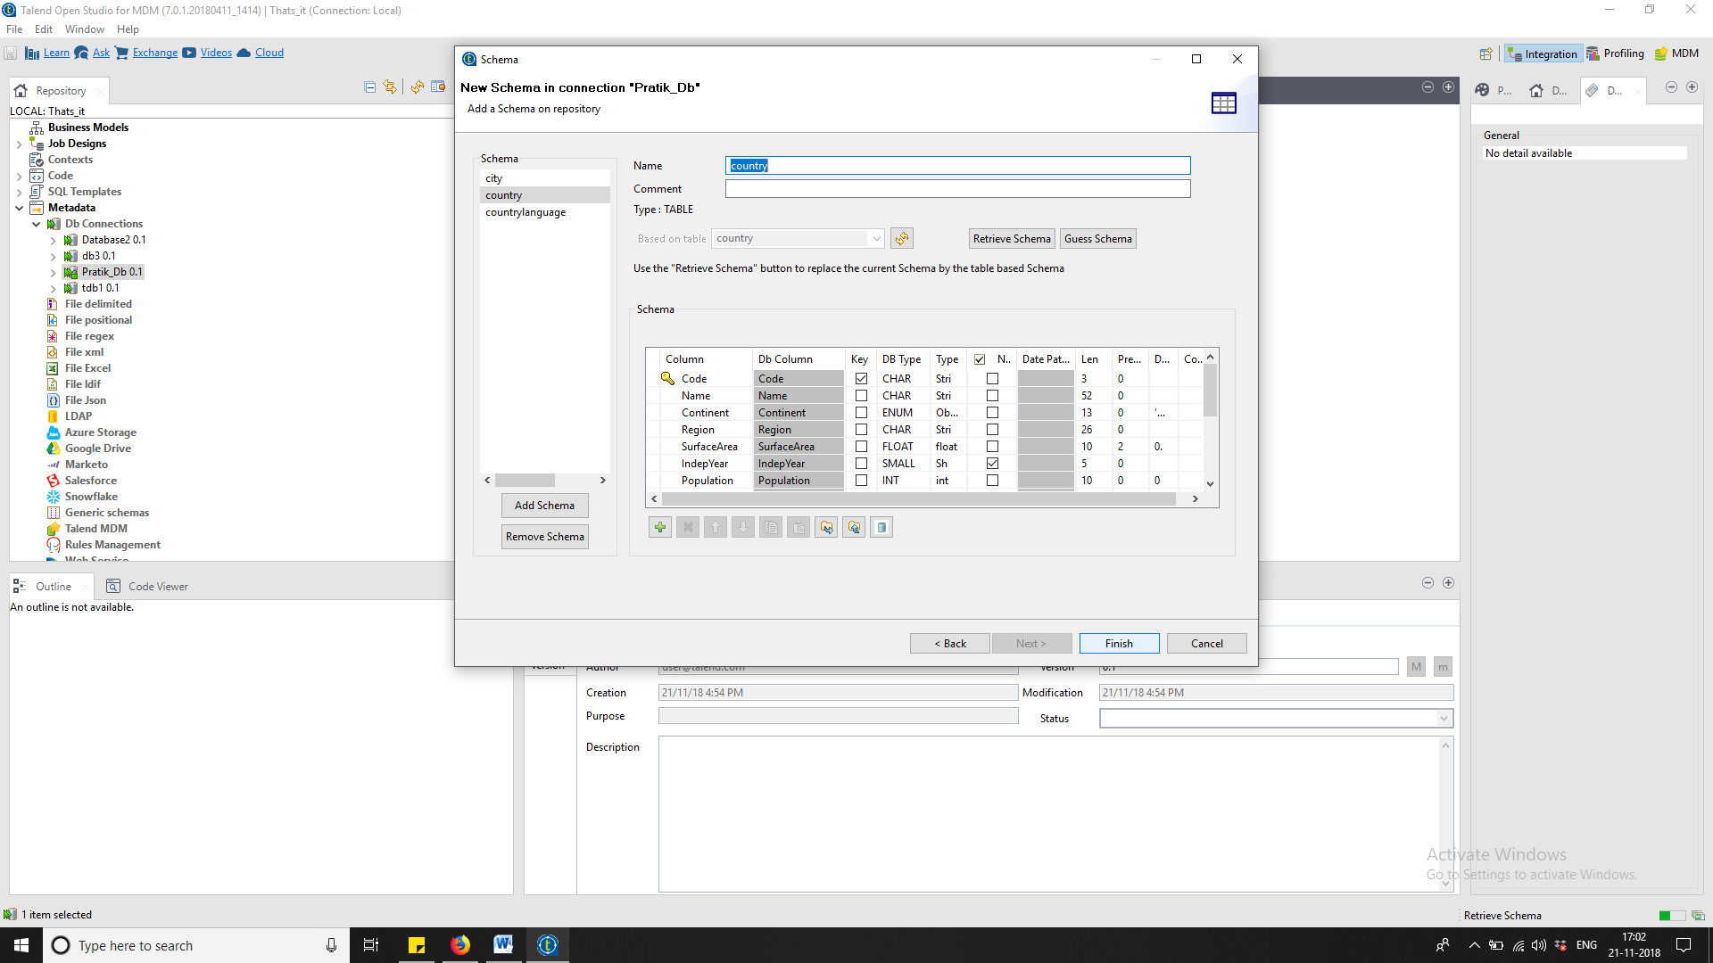

1. Create a job then select tdbInput from palette. Then use tlogrow for displaying the contents of tdbinput.

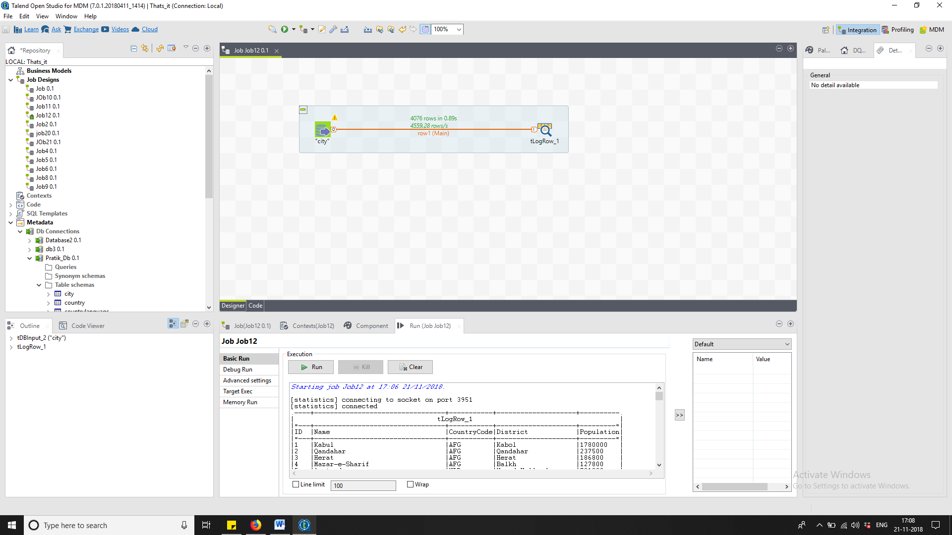

1. Using Tbrow for making changes in a particular table in our database.

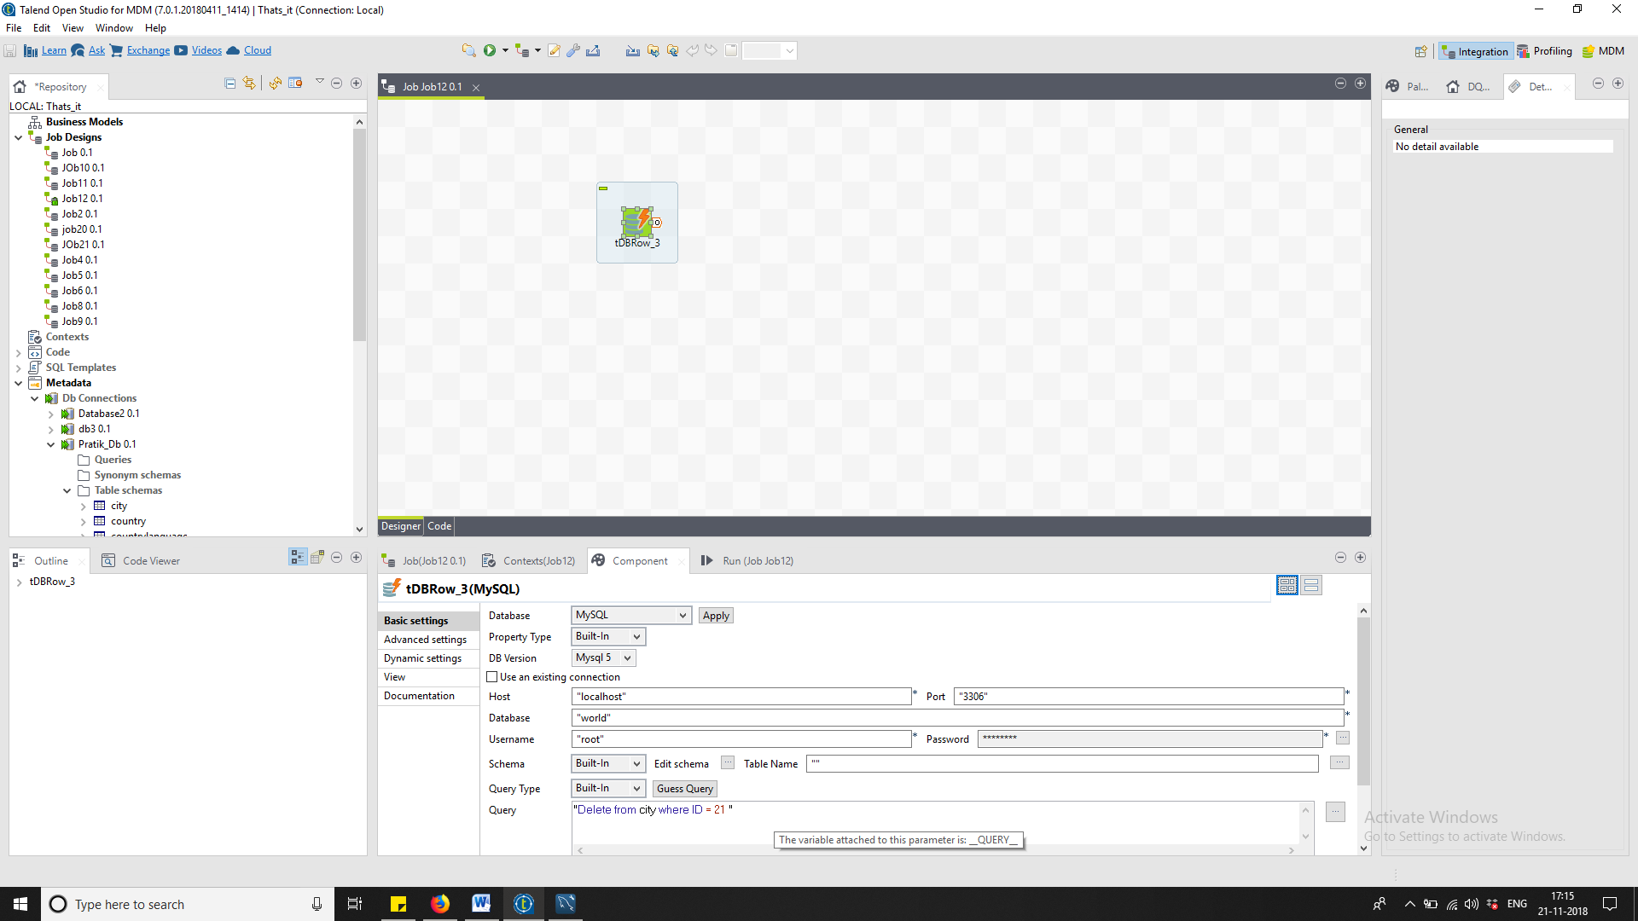

1. As u can see one record is deleted where ID =21

